**Exercise 2: Format Phone Numbers in a Standard Format**

Using the function REGEXP_REPLACE(), format all phone numbers in the Customers table to a standard format (XXX) XXX-XXXX.

Test: Apply this formatting to the Phone column and display the first 10 formatted phone numbers.

-- Task_02.sql

-- Format phone numbers exactly to the format (XXX) XXX-XXXX

-- I used exactly format of (XXX) XXX-XXXX as its required

-- It says first 10 but there are no numbers with this exact format 10 there are 8

-- However used limit 10

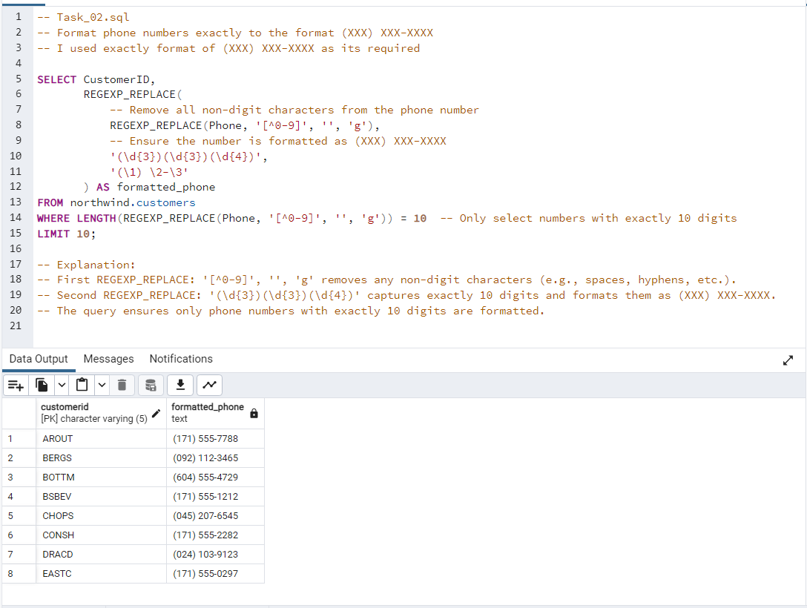

-- Explanation:

-- First REGEXP_REPLACE: '[^0-9]', '', 'g' removes any non-digit characters (e.g., spaces, hyphens, etc.).

-- Second REGEXP_REPLACE: '(\d{3})(\d{3})(\d{4})' captures exactly 10 digits and formats them as (XXX) XXX-XXXX.

-- The query ensures only phone numbers with exactly 10 digits are formatted.